Stakeholder Analysis 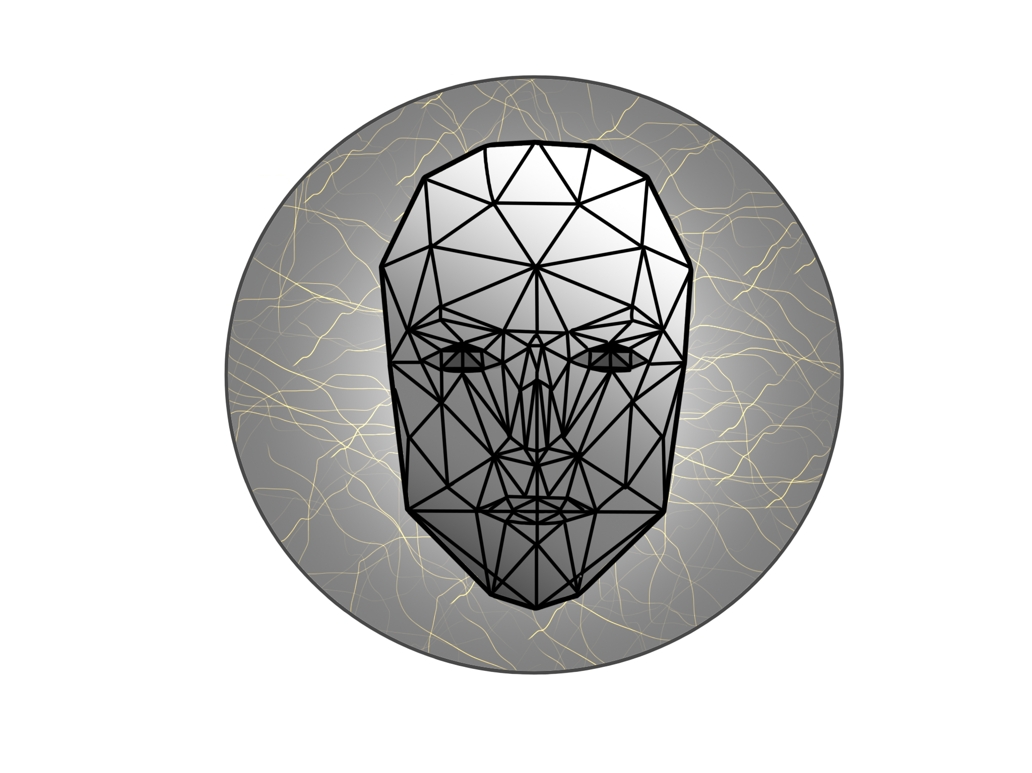

## Who our stakeholders are?

* ASPI foundation authorities
* People with autism
* Supervisor - dr hab. inż Piotr Napieralski
* Facecoders team
* Team Building tutor - mgr Iwona Wróblewska
* Prospective customers (companies, foundations in need of emotion detection)
* Android using mobile community
* Learning individuals/ Amature programmers (studying the app implementation of an exemplary material)

Power/Interest Grid for Stakeholder Prioritization

* Manage closely (Power - High; Interest - High)

Supervisor, Our Team

* Keep satisfied (Power - High; Interest - Low)

People with autism, Team Building tutor

* Keep informed (Power - Low; Interest - High)

ASPI foundation

* Monitor (Power - Low; Interest - Low)

Potential users, Prospective customers

Stakeholders groups

Except from dividing our stakeholders into Power/Interest groups we also can group them into the following groups:

* Scholastic/Academic

This group consists of all the people connected to the project or the Lodz University of Technology itself and those who look at the project from the scientific point of view. There are the supervisor, the tutor, university administratives, the facecoders team and Learning individuals.

* Commercial customers

Any companies, enterprizes, enthusiasts and specialists are interested in the application usage, technology used in it or testing the result. Includes ASPI foundation authorities, prospective customers, etc.

* General users

The regular customers using an app on general bases like entertainment, curiosity, testing. This group may have a big difference in age, gender and other characteristics.

Motivation of stakeholder groups

* Scholastic/Academic

Directly interested in the success of the team project. A valuable product of ours will increase the university prestige, give recognition from university authority to the supervisor, tutors and the team.

* Commercial customers

The product can increase profit of the company, modernize and optimize the services and tools of the company. In particular the application is interesting for ASPI foundation to use in socialization and rehabilitation for children suffering from autism. Our project will provide an interactive, modern and entertaining method to distinguish human facial expressions and emotion.

* General users

The motivation of this group can be different and strongly dependent on the feedback left by the users. Also to motivate this group we have to provide a proper documentation and to support the application after release by adding features and improving the accuracy and quality of the product. Still the motivation can be entertainment, testing of an application and its efficiency.

Communication with stakeholders

During the development process our team was in touch with ASPI foundation and children with the autism. Because our application was mainly designed to meet the specific requirements of those, we several contacts discussing the need of such product, and an interface design in particular.

Also we were always consulting with our supervisor to follow best practices, having access to needed resources (databases, study materials) and meet the requirements for the course finishing.

Opinion of stakeholders

Opinions on our application will depend on if the certain motivation of a specific stakeholders group is pleased.

At this point we received positive feedback from the supervisor, ASPI foundation, children studying at this foundation and some potential users. Still currently the application is too raw for the commercial use or to be a mindblowing product for the general users.